Array in Java With Exmaples:
Array : It is a bunch or you can say group of variables with same data types.
We already discussed primitive data types of java. Java has three reference data types.

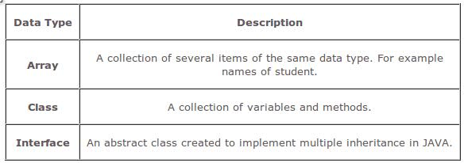

NOTE :Class and interface we discuss later in further chapter.

We have one dimensional and multidimensional array in java. It works differently compare to C and C++ language.
Arrays can be declared in three ways:
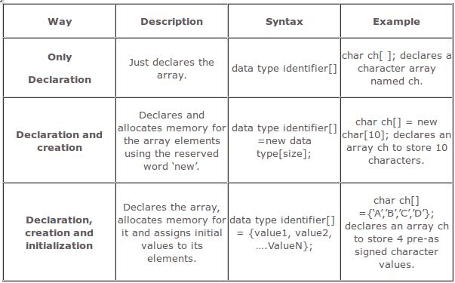

From the above table let me tell you one thing here we declare one char type array and size of that array is 10. So we have 10 different char type variables like ch[0] to ch[9]. Value in the square bracket is called index of the array and index value of any array always start from 0.

Syntax :

One dimensional array :

Declaration syntax : type var-name[ ];

EX.

int month[ ];

Here we just declare month variable of type int array. But actually or physically no array exist. To link this array into actual physical array of integers we have to use new keyword.

Syntax : array-var = new type[size];

EX.

month = new month[12];

So obtaining an array is a two-step process. First, you must declare a variable of the desired array type. Second, you must allocate the memory that will hold the array, using new, and assign it to the array variable. Thus, in Java all arrays are dynamically allocated.

So now we have 12 different int type variable month[0] to month[11].

It is possible to combine the declaration of the array variable with the allocation of the array itself like...
int month[] = new int[12];
Multidimensional array :
Declaration syntax : type var-name[ ][ ];
EX.
int mat[ ][ ] = new int[4][5];
In Java, multidimensional arrays are actually arrays of arrays. To declare a multidimensional array variable,specify each additional index using another set of square brackets.
This allocates a 4 by 5 array and assigns it to mat. Internally this matrix is implemented as an array of arrays of int. Conceptually, this array will look like the one shown in figure.

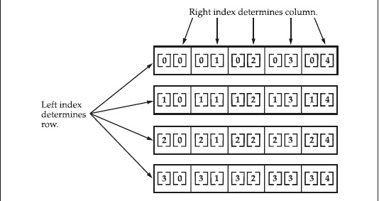

Ex:-printing the array elements
class Test
{
public static void main(String[] args)
{
int[] a={10,20,30,40};
System.out.println(a[0]);
System.out.println(a[1]);
System.out.println(a[2]);
System.out.println(a[3]);
}
}

Ex:-printing the array elements by using for
loop

class Test
{
public static void main(String[] args)
{
int[] a={10,20,30,40};

for (int i=0;i<a.length;i++)

{
System.out.println(a[i]);

}
}
}

Ex:-printing the array elements by using for-
each loop(1.5 version)

class Test
{
public static void main(String[] args)
{
int[] a={10,20,30,40};
for (int a1:a)
{
System.out.println(a1);
}
}
}

Ex:-
import java.util.*;
class Test
{
public static void main(String[] args)
{
int[] a=new int[5];
Scanner s=new Scanner(System.in);
System.out.println("enter values");
for (int i=0;i<a.length;i++)
{
System.out.println("enter "+i+" value");
a[i]=s.nextInt();
}
for (int a1:a)
{
System.out.println(a1);
}
}
}

